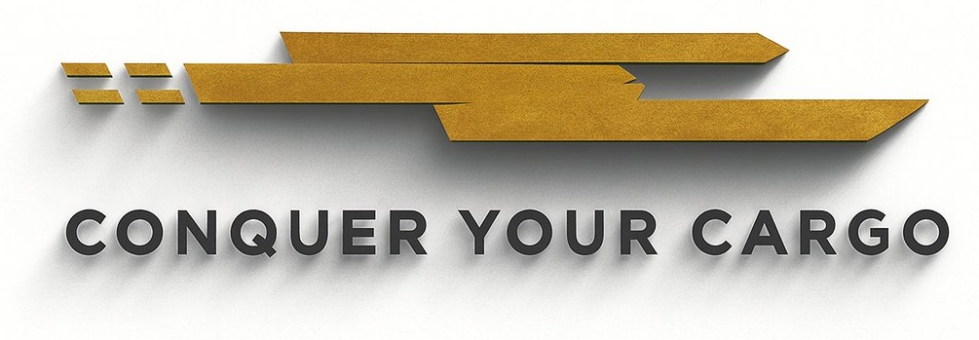

BROKER RATE SCHEDULE & FEE ACKNOWLEDGMENT

This Rate Schedule and Fee Acknowledgment constitutes the complete fee schedule for services provided by Cargotron INC. All fees are in U.S. Dollars. Government-assessed charges (duties, taxes, fees, penalties) are NOT included and are passed through at cost. Fees are subject to change upon thirty (30) days' written notice.

▌ SECTION 1 — STANDARD BROKERAGE FEES

SERVICE | STANDARD FEE | NOTES
Customs Entry Filing — Formal Entry (Type 01) | $50.00 per entry | Includes ABI transmission
ISF / 10+2 Filing | $25.00 per ISF | Ocean shipments only
Informal Entry Filing (Type 11) | $__________ per entry | Quote on request
Post-Entry Amendment (CBP Form 5173) | $__________ per amendment
Protest Filing (CBP Form 19) | $__________ per protest
Prior Disclosure Preparation | Quote on request | Attorney referral may apply
CBP Binding Ruling Request — Broker Support | Quote on request | Broker support only
Duty Drawback Claim Assistance | Quote on request | Per arrangement
C-TPAT Application Assistance | Quote on request | Per arrangement
HTS Classification Research (complex items) | $__________ per item | Quote on request
Annual Continuous Bond Arrangement | $__________ per bond | Surety-dependent
Single Entry Bond Arrangement | $__________ per bond | Surety-dependent

▌ SECTION 2 — PASS-THROUGH GOVERNMENT CHARGES

The following are government-assessed charges passed through to Client at actual cost with no markup unless otherwise specified:

CHARGE TYPE | RATE / BASIS
U.S. Customs Duties | Per CBP liquidation at applicable HTSUS rate
Merchandise Processing Fee (MPF) | 0.3464% of entered value (min $32.71 / max $614.35)
Harbor Maintenance Fee (HMF) | 0.1250% of entered value — ocean shipments only
Anti-Dumping / Countervailing Duties (AD/CVD) | Per CBP AD/CVD order — varies by case
CBP Exam Fee (VACIS / CET / Tailgate) | Actual cost — varies by port and exam type
FDA Prior Notice / Registration Fees | As assessed — varies by product
USDA Inspection / Permit Fees | As assessed — varies by commodity

▌ SECTION 3 — BILLING & PAYMENT TERMS

- Invoices issued within two (2) business days of entry release or CBP liquidation, whichever is earlier.
- Standard payment terms: Net 30 from invoice date unless otherwise agreed in writing.
- Duty advances: due within five (5) business days unless F-04 specifies extended terms.
- Payments accepted: ACH, wire transfer, or check payable to CARGOTRON INC.
- Past-due balances accrue interest at 1.5% per month (18% per annum).
- Client is responsible for all collection costs including reasonable attorneys' fees.

▌ SECTION 4 — FEE ADJUSTMENT NOTICE

Cargotron INC. reserves the right to adjust fees upon thirty (30) days' written notice to Client. Continued use of Broker's services following the effective date of any fee adjustment constitutes Client's acceptance of the revised schedule.

▌ SECTION 5 — CLIENT ACKNOWLEDGMENT

The undersigned Client acknowledges receipt of this Rate Schedule, confirms understanding of all fees listed herein, and agrees to be bound by the billing and payment terms set forth above.

EXECUTION
CLIENT — AUTHORIZED REPRESENTATIVE |  | CARGOTRON INC.
Authorized Signature |  | Authorized Signature
Printed Name & Title |  | Printed Name & Title
Date |  | Date

