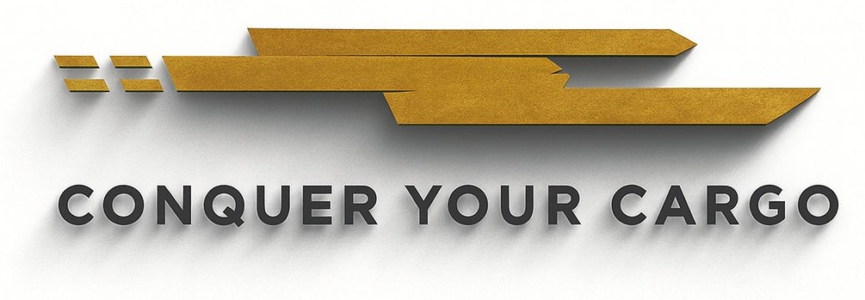

CLIENT ONBOARDING & KNOW YOUR CUSTOMER (KYC) FORM

All information collected is used for compliance verification, client due diligence, and regulatory screening consistent with 19 CFR §111.29 and applicable AML best practices. Complete all sections in full.

▌ SECTION 1 — BUSINESS IDENTITY

Legal Name of Business

DBA / Trade Name (if any)

State / Country of Incorporation

Date of Formation / Incorporation

Federal EIN / Tax ID

DUNS Number (if applicable)

CBP Importer of Record (IOR) Number

Business Physical Address

Mailing Address (if different)

Primary Business Phone

Primary Business Email

Website

Type of Entity:
☐ Corporation | ☐ LLC | ☐ Partnership | ☐ Sole Proprietor

▌ SECTION 2 — NATURE OF BUSINESS

Primary Business Activity

Primary Product(s) Imported

Countries of Origin (list all)

Estimated Annual Import Value (USD)

Estimated Monthly Entry Volume

Primary Port(s) of Entry

Primary Supplier / Manufacturer

Primary Shipping Mode:
☐ Ocean | ☐ Air | ☐ Rail | ☐ Truck / Ground

Does Client use a freight forwarder?
☐ Yes — Name: | ☐ No

▌ SECTION 3 — AUTHORIZED CONTACTS

NAME | TITLE | PHONE | EMAIL

▌ SECTION 4 — REGULATORY & COMPLIANCE SCREENING

Answer all questions truthfully. Any "Yes" answer requires a written explanation attached to this form.

COMPLIANCE SCREENING QUESTION | YES | NO
Has the company or any principal ever been assessed a CBP penalty, fine, or liquidated damages? | ☐ | ☐
Has the company or any principal ever had import privileges suspended or revoked? | ☐ | ☐
Is the company or any principal currently under federal investigation (CBP, DOJ, or other agency)? | ☐ | ☐
Is the company or any principal listed on the OFAC Specially Designated Nationals (SDN) list? | ☐ | ☐
Is the company or any principal listed on the BIS Denied Persons List or Entity List? | ☐ | ☐
Has the company imported goods subject to Anti-Dumping or Countervailing Duty (AD/CVD) orders? | ☐ | ☐
Does the company import goods regulated by FDA, USDA, EPA, FWS, or any other PGA? | ☐ | ☐
Has the company ever been denied services by a prior customs broker? | ☐ | ☐

▌ SECTION 5 — CERTIFICATION

The undersigned certifies that all information provided in this form is true, accurate, and complete. The undersigned authorizes Cargotron INC. to verify the information provided and screen against government watchlists (OFAC, BIS, CBP). Misrepresentation may result in immediate termination of services and referral to appropriate authorities.

EXECUTION
AUTHORIZED REPRESENTATIVE — CLIENT |  | CARGOTRON INC. — COMPLIANCE
Authorized Signature |  | Authorized Signature
Printed Name & Title |  | Printed Name & Title
Date |  | Date

